**What’s OFF About Vanity Sizing**

By: Ananya Chetia

To slip into a new pair of size double zero jeans felt like an achievement, said Aleena Ahmed, a resident of New Jersey.

“I didn't even want to take the tag off,” she said about her American Eagle jeans. “It was like a marker of 'I did it.'”

Perhaps it was her slim tall Barbie dolls growing up or the eruption of skinny beauty standard posts titled “Thinspo” on Tumblr, but Ahmed said she would eat less to be thinner. New clothes could monitor the progress.

So when the double zero jeans from Old Navy didn't fit, even though the ones from American Eagle did, Ahmed said it tripped her out and made her “feel unattractive.”

Different jean sizes fitting Ahmed is an example of vanity sizing, where clothing brands label their clothes smaller than they actually are. This means there's no consistency across brands when it comes to what the measurements for each size actually are.

From the dataset I built, no two brands had matching measurements between sizes XS to XL. High-end brands like AMO, AYR and Agolde had a smaller range of hip sizes from XS to XL compared to fast fashion brands like Old Navy or Ambercrombie & Fitch.

[**CHART ONE]**

*FOR MORE DETAILS ON THIS CHART, SCROLL TO THE LAST PAGE.*

For Ahmed, the numbers on a pant's tag measured her self-worth.

"Logically, I understand that my health is important," Ahmed said. "There are moments I get bad at it, just to see a pair of small pants not tighten up on my stomach."

[Research](https://www.sciencedirect.com/science/article/abs/pii/S1057740813000612?fr=RR-2&ref=pdf_download&rr=926bde3029fc41c3) shows one's mental image about being a larger size than what a size tag states may be detrimental to self-worth.

Critics say there are downsides to a universal size guide too. Given the vast differences in body types and sizes, it would be impossible to develop a size guide accommodating every person. As an article from [sizebay](https://sizebay.com/en/blog/why-clothing-sizes-are-inconsistent-across-brands/#:~:text=Bodies%20are%20not%20standardized,-Universal%20sizing%20is&text=But%20in%20practice%2C%20universal%20sizing,measurements%20are%20based%20on%20data) put it, “standard measurements and sizing will never be able to capture the nuances and unique fit and style preferences of every single shopper."

According to the [Centers for Disease Control and Prevention,](https://www.cdc.gov/nchs/fastats/body-measurements.htm) the average waist size for women is 38.7 inches. Yet majority of the brands in this dataset categorize this average waist size as large (L) or even extra large (XL). Despite branding itself as “one size fits all,” Brandy Melville excludes the average woman’s size by selling jeans with a 30-inch waist.

Brands design their own size guides to cater to their audience and make consumers feel good about purchasing clothes as a size small, said Patience Billingsley, a graduate of the University of Arkansas, where she conducted research on vanity sizing.

"[Vanity sizing] is also unethical and it can be manipulating to tell customers a size they are not," said Billingsley.

Because vanity sizing misleads shoppers, consumers often order the same item in different sizes to see what works. With the rise of online shopping—especially since the 2020 pandemic—the trend of over-purchasing and returning what doesn’t fit has only grown.

Returning packages seem harmless, but it hits brands' profits and fuels emissions and landfill waste.

[**CHART TWO]**

*FOR MORE DETAILS ON THIS CHART, SCROLL TO THE LAST PAGE.*

Returned retailed packages led to 8.4 billion pounds of waste in 2023, according to a report from [Optoro](https://4771362.fs1.hubspotusercontent-na1.net/hubfs/4771362/The%20State%20of%20Returns%20Report%202024%20%E2%80%94%20Optoro.pdf) Meanwhile [24 million metric tons](https://www.imrg.org/blog/sustainable-ecommerce-returns-arent-working-its-time-for-a-circular-approach/?utm_source=chatgpt.com) of emissions were released from transporting returned goods in 2022.

The variety in what constitutes a “small” waist or “large” bust in clothes makes the concept of what our sizes actually are irrelevant, Ahmed said.

Despite vanity sizing being inconsistent across major brands, clothing size and body image are a persistent thought for Ahmed. That's what hurts the most, she said.

“I want my life to be bigger,” Ahmed told me. “This is the physical body I have and I want my life to be about other things.”

***See charts in the next place.***

**Previous chart:**

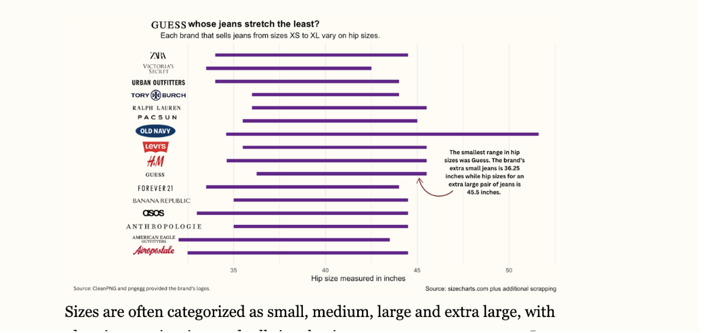

**Summary of the feedback I received:**

Feedback informed me that this chart was confusing. It was hard to understand what was the point of this chart because the headline was confusing. Also, the bars are clumped tightly near each other and it's hard to detect which bar represents which brand. 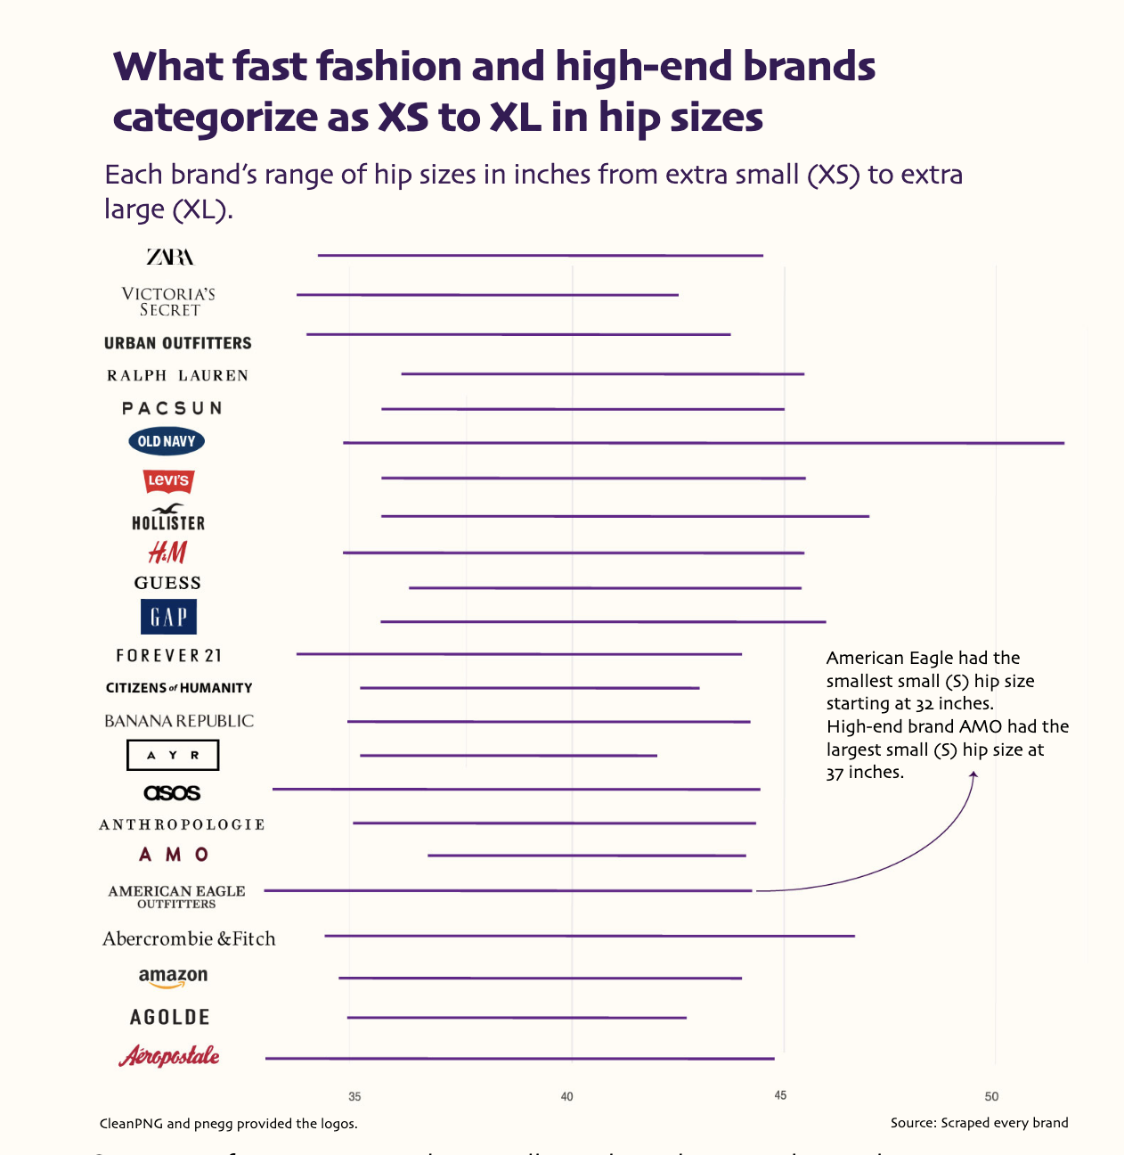

**New Chart**

**Changes I made to this chart:**

* Changed the header
* Made the artboard bigger so I can space out the bars.

**What you feel is successful about your new chart**

* The title clarifies that I am looking at what each brand categorizes as XS to XL. It’s not about individually looking at XS, S, M, L or XL. It’s about just seeing the range of XS to XL and how it differentiates per brand. I maintained the aesthetic because I believe it matches the story well.

**What you learned by remaking the chart**

* I learned about readjusting artboards on illustrator and making it presentable on my website. It was not working for a while. I messed with the artboard and made it 787 px. But, I was able to get into the html and write in the height to make it 787 px. It was a simple fix that was initially frustrating.

**Previous second chart:**

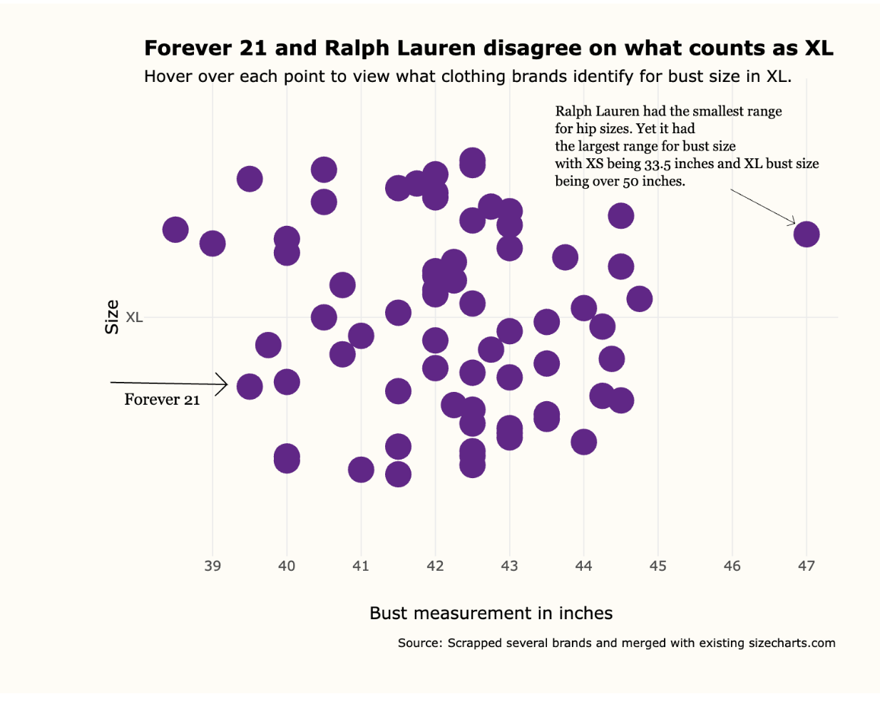

**Summary of the feedback I received:**

Everyone told me this chart was incredibly confusing. The y-axis being XL didn’t make sense. The header saying Forever 21 and Ralph Lauren “disagreeing” could be factually incorrect (because they didn’t *actually* disagree!) Additionally, having this chart be interactive isn’t the best because readers are lazy. They just want us to get to the point! I did like my annotation on Ralph Lauren here though, because it was an outlier.

**New Chart**

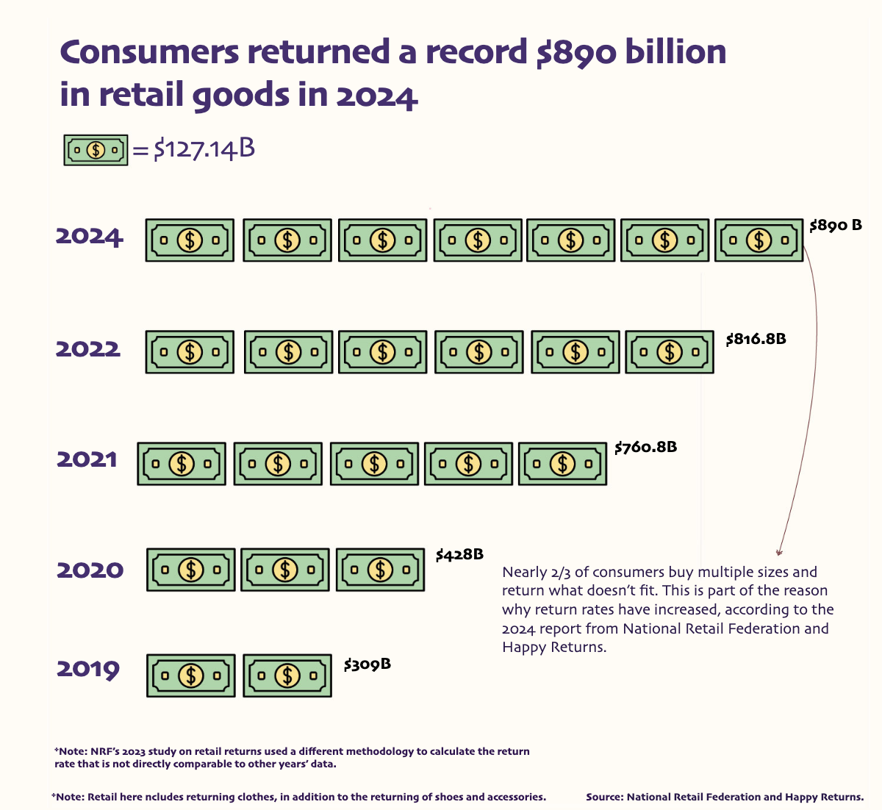

**Changes I made to this chart:**

* This is a NEW chart! The reason I abandoned the old one was because it was repeating the same message as the old chart, which is that vanity sizing exists and there is a variety in what counts as a small or medium, etc. So, I researched more into how vanity sizing impacts brands and the environment. From there, I found a dataset on how much retail returns added up to, which was the highest in 2024. The report explicitly mentioned that part of why retail returns increased is because consumers purchase a lot of sizes because they don’t know their size. Vanity sizing makes it difficult to know what one’s size actually is!

**What you feel is successful about your new chart**

* This chart is simple. It’s just explaining that if you added up all the retail returns (meaning the cost of each retail) it would add up to almost 900 billion. I like this chart other than my old one because this chart *adds* to this story. It’s not repeating the chart that I had before. It explains a new angle of vanity sizing. I also did try to find datasets on how returning clothes back to brands impacts the environment, but I could not find a dataset on this. This dataset I published was the cleanest and most factual.

**What you learned by remaking the chart**

* This was the first time I made a chart completely using an illustrator. I did some math to ensure that each dollar sign equated to $127.14B. I realized now, after making this, that I could have made both charts transparent to add some texture to my CSS background (like a jean, fabric material since we are talking about clothes?) I will try to make these changes post submitting this.